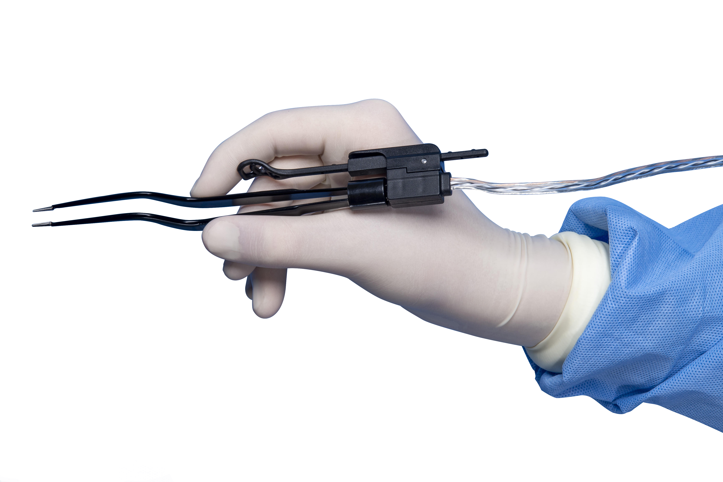

Hospital Product Shipment Approval Form

PO ATTACHED: Y N PO #: ______________ N/A, PAY BY _______
Date Requested: ______________ Date of last order: ____________
Date of first Surgeon CALL to this account: _________
Total # of product shipped to this account: ______________
Salesperson Name: _____________________________ SPID: ______
Sale Group Name: ________________________________
Sales Group Director’s Name: _____________________________
Hospital Name: ______________________________ Account #: __________
City, State:________________ Name of Parent Hospital: _______________
# of Beds: _____________. 1° Contact Name: __________
Total # of surgeons at this facility: _______
# of product requested: BP105M_______. BP105C ______ BP105CY ____
Negotiated Price: ________ [ ] standard pricing. [ ] Special
Completed by BSSM: _____________________ Date: _______
Notes: __________________________________________________
_________________________________________________________
IS THIS ACCOUNT CURRENT: Y N Date of last payment: ____ Net: ___d
Sign off by: Louis Cornacchia, CEO.
Signature: _____________________________ Date: _____________
Comments:

